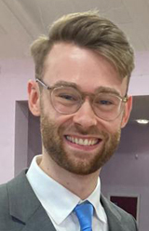
JOE REEVES first moved to Leeds from London in 2012 to study BA Music at the University of Leeds. He completed a Choral Conducting Scholarship at Leeds Cathedral and worked as a freelance community musician for five years. His work included a music and dance project working with people living with dementia, running community shows as musical director as well as a variety of other music and theatre focused youth groups. He became conductor for The Wendel Singers in 2018 after the retirement of Joe Roberts. Over the past three years, Joe has volunteered at Leeds North and West Food bank and began working in mental health. Now, he is a social prescriber, supporting and connecting people with services that can help them make positive changes in their lives.
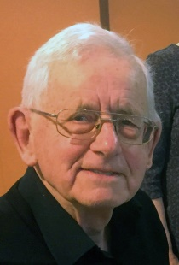
PETER REASBECK studied piano with Elsie Werren in Doncaster and music at Doncaster Grammar School, before reading classics at Durham and theology at Cambridge. As a Methodist minister for over 40 years, he continued to develop his musical abilities and has specialised in accompaniment for lieder and in playing the organ for church services. In retirement he is active as an accompanist for vocal & instrumental soloists and choirs. He has many interests including gardening, bee-keeping and Leeds Rhinos.
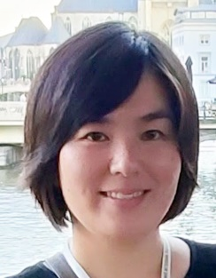
YUKA OEDA, who comes from Hiroshima, Japan, is a lecturer in Japanese at the University of Leeds. After spending a couple of years in Leeds she decided to bring with her the flute which she used to play as a high school student, that was sitting back at home in Japan, and she started taking flute lessons. She has recently achieved a Distinction in the ATCL Performance Diploma and enjoys playing with the Christopher Irvin Orchestra and various ensembles in Leeds.

Harmony & Humour
—an autumn programme of entertainment by
The Wendel Singers

Conductor: Joe Reeves
Piano: Peter Reasbeck
Flute: Yuka Oeda

at St Mary’s Church Whitkirk Community Centre
at 2.30pm on Saturday 28th October 2023

Programme

Part 1
Let there be music Gordon Young
Something told the wild geese P. Back, arr. B.D. Hawer
Interlude: Pauline Duncan Austin
Diary of a Church Mouse, by John Betjemann
Little David, Play on Yo’ Harp
Afro-American spiritual arr. Malcolm Sargent
The Lily of the Valley
Afro-American spiritual arr. Wendell Whalum
Flute & Piano Duet: Two movements from Suite for Flute
and Piano by Benjamin Godard (1889)
Look at the World John Rutter
Glorious is Thy Name From the Twelfth Mass,
Wolfgang Amadeus Mozart
Interlude: Stan Pearson You Are Old, Father William by
Lewis Carroll
The Heavens are Telling Chorus from The Creation,
Josef Haydn

INTERVAL

Part 2

Let the Earth Resound Sally K. Albrecht
The Music of the Night Music by Andrew Lloyd Webber,
Lyrics by Charles Hart, arr. Ed Lojeski
Last of the Summer Wine Ronnie Hazlehurst
arr Mike Sammes, John Summerwill & Joe Reeves
Flute & Piano Duet:
Annie's Song John Denver. arr James Galway
Top of the World John Bettis/Richard Carpenter
The Water of Tyne North-country folk tune arr. W.G. Whittaker
Homeward Bound Marta Keen, arr. Jay Althouse
Interlude: John Summerwill Just For A Laugh
A London Medley George & Ira Gershwin, Manning Sherwin,
Eric Maschwitz, Irving Berlin, arr. A. Kyle

THE WENDEL SINGERS

The Wendel Singers is a mixed choir of forty voices. We sing a great variety of four-part choral music, mainly short pieces, ranging from renaissance to contemporary, both religious and secular, just for the sheer pleasure of being together making music, performing occasional concerts anywhere in the Leeds area.

The choir originated as the Barwick-in-Elmet Townswomen’s Guild Choir. After 1974 it became the Elmete Singers, still a women’s choir, which competed in the Pontefract Music Festival as well as performing concerts. In 1980 it became The Wendel Singers, taking its name from Wendel Hill, the site in Barwick of an iron age hill fort and later a Norman castle. After the pandemic our rehearsals moved for more space to Lidgett Park Methodist Church, where the choir now meets on Wednesdays from 7.45 to 9.15pm.

Over the years it has had a number of conductors, including Adam Tomlinson (now at Radio York), Forbes Doig, David Fligg and Glenys Heywood. Around 2006 its number had dwindled to single figures, but it gained a new lease of life when Joe Roberts took over as conductor and brought in new members, building our strength to more than 30 singers. After his retirement, his successor, Joe Reeves, has led us to a performance that gained a merit in the Rothwell Music Festivals in 2019 and 2023, and a commendation and First Prize in the 2022 festival.

